Functionality Testing Document

- Overview

Project Title: Unemployment Rate Forecasting Dashboard
Date: 8/10/25
Prepared by: Ieuan Esteban
Test conducted by: Justin Regidor, Ieuan Esteban, Anjali de Silva
Environment: Power BI

Purpose
The purpose of this Functionality Testing Document is to verify that each component of the Unemployment Rate Dashboard operates as intended. This includes ensuring that all visuals, filters and data interactions perform correctly, calculations are accurate and that the dashboard responds as expected under normal user operations. The goal is to confirm that all features align with the deliverables and that users can confidently interact with the dashboard without encountering any functional errors.

- Objective

- Validate that each interactive element works as intended
- Ensure all key metrics display accurate and current data
- Confirm data connections refresh successfully without fail
- Test that each visualization dynamically updates based on user inputs
- Verify navigation between dashboard pages function smoothly.

- Test Participants

Participant Name | Role
Justin Regidor | Programmer/Data Analyst
Ieuan Esteban | Researcher/Documenter
Anjali De Silva | Project Advisor

- Test Scenarios

Test ID | Scenario Description | Test Method | Expected Outcome | Actual Outcome | Status
FT01 | Verify that all slicers (gender, region, ethnic, age) are correctly paired with visuals | Interact with each slicer and observe corresponding visual changes | Each slicer will filter its graph or visual without delay or error | European South Island option does not work (Actual Category, European Regional Council) | fail
FT02 | Confirm that the region slicer filters the regional average line graph | Select multiple or single regions using the Region slicer | Regional average bar graph updates accurately to reflect only the selected regions | European South Island option does not work (Actual Category, European Regional Council) | fail
FT03 | Validate that the demographic slicer filters the ethnic average unemployment rate graph | Apply filter through the Demographic slicer | Ethnic average graph updates to display the filtered ethnicities | Ethnic average graph updates to display filtered ethnicities | Pass
FT04 | Ensure that slicers correctly filter data in connected graphs without affecting unrelated visuals | Use slicers in sequence | Only related visuals update, unrelated visual remain unaffected | Only updated related visuals. | Pass
FT05 | Test that navigation buttons link correctly between dashboard pages | Click each navigation button and observe transition | Smooth navigation between pages without broken links or lag | Smooth navigation with no broken links. | Pass
FT06 | Check heatmap interactivity when clicking individual cells | Click on heatmap cells across various regions | Regional average graph updates according to selected region, ethnic average graph remains unchanged | Heatmap was removed however new change works | pass/fail
FT08 | Confirm hover tooltips on graphs display correct average values | Hover over bars, lines or cells in visuals | Pop up tooltip appears showing the accurate average for that specific filter | Tooltip appears when hovering over a point in graphs | Pass
FT09 | Test that buttons and slicers do not cause display or calculation errors | Perform multiple slicer changes, hover actions and navigations | Dashboard remains responsive, visuals refresh dynamically without error or distortion. | Dashboard is responsive, visuals refresh without error. | Pass

- Feedback Summary

Participant | Feedback Summary | Issues identified | Action Taken
Ieuan Esteban | Overall the functions are working as expected. | The only issue I had come across was the one option under ‘European South Island’ under Actual Category European Regional Council | Have reported to Robert.

- Results Summary

Overall the dashboard demonstrated strong functionality stability with six tests passing successfully. Core functionalities such as demographic and regional slicer responsiveness, navigation between pages, tooltip accuracy and overall dashboard responsiveness under multiple interactions performed as expected.

Two failures were identified and are both linked to the “European South Island” option under the actual category, European regional Council which did not function correctly in the slicers. This can be seen in the screenshot below.
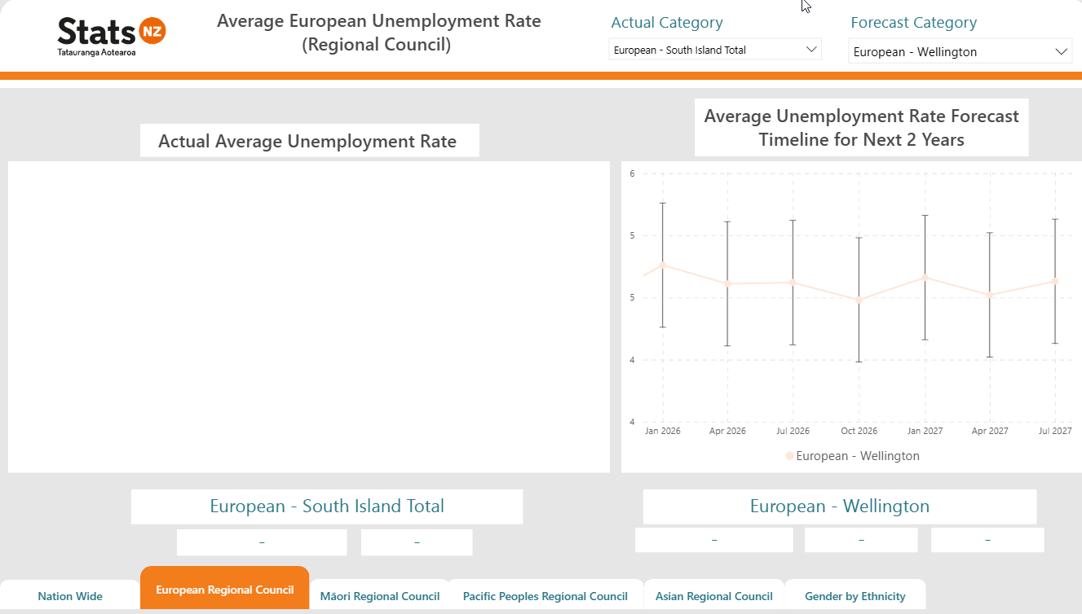
Despite these issues, the dashboard overall demonstrated a high level of functional reliability. Key interactive features are stable, user friendly and accurately reflect the underlying dataset.

